A Complete Guide to Creating a Balcony Garden
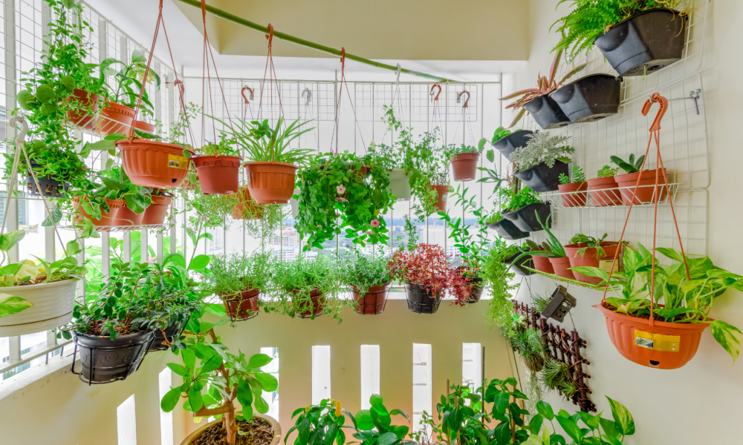
A balcony garden is a beautiful way to bring nature closer. It is especially so for city dwellers with limited outdoor space. A small balcony can become a lush oasis or a herb corner, a floral repeater or even a vegetable patch. All this can be possible with the right planning. Here is a complete beginner-friendly guide to building a thriving balcony garden inspired by modern urban gardening trends.
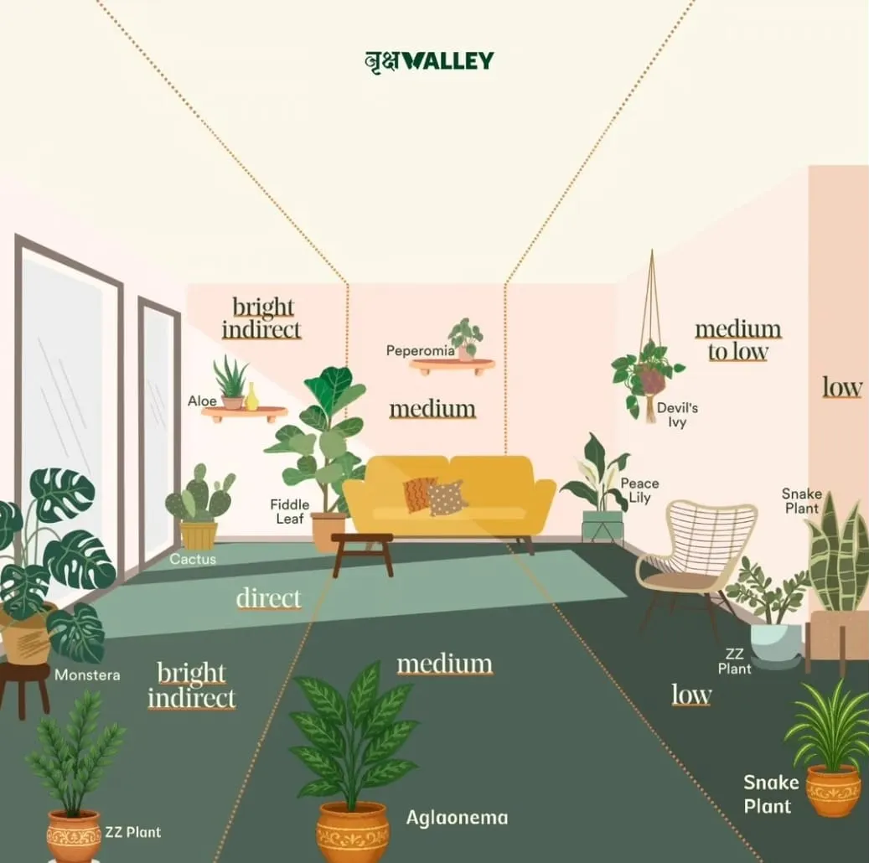

Step 1: Understand the Light Conditions of Your Balcony
Observe how much sunlight your balcony receives before selecting plants.

Full sun
It must receive sunlight for more than 6 hours. It is great for succulents and herbs as well as vegetables.

Partial sun
It must receive sunlight for 3 to 5 hours. It is ideal for floating plants.

Shade
The sunlight availability is for 1 to 2 hours. It is perfect for ferns or snake plants, and ZZ plants.
Understanding this one factor influences everything from plant choice to watering frequency.
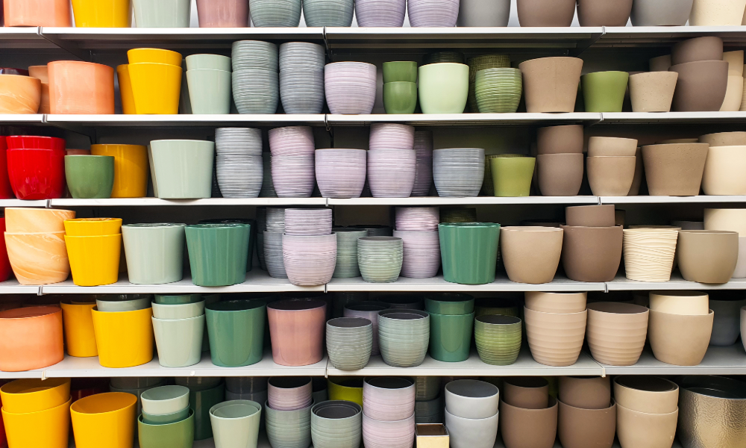

Step 2: Choosing the Right Containers
Containers are more than just holders. They influence growth and water flow as well as root health of the plants for balcony.
Here are some of the best pot choices for balconies.
- Terracotta pots are breathable and prevent overwatering.
- Plastic pots are lightweight and budget-friendly.
- Grow bags are perfect for vegetables and herbs.
- Hanging pots, which save floor space.
- Vertical panthers, which are great for compact balconies
Ensure that all containers have drainage holes.
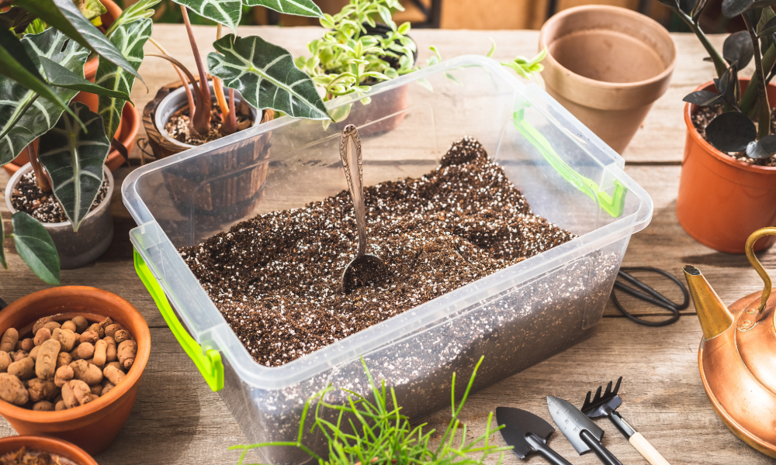

Step 3: Using the Right Potting Mix
Balcony garden plants need lightweight, well-draining, and airy soil.
The following is the right percentage for general plants.
- 50% garden soil
- 25% cocopeat
- 25% perlite or sand
The following is the right culture for succulents.
- 60% sand
- 30% soil
- 10% small stones/grit
The following is the right mixture for vegetables.
- 40% compost
- 40% garden soil
- 20% cocopeat
It ensures that roots get oxygen while retaining enough moisture.
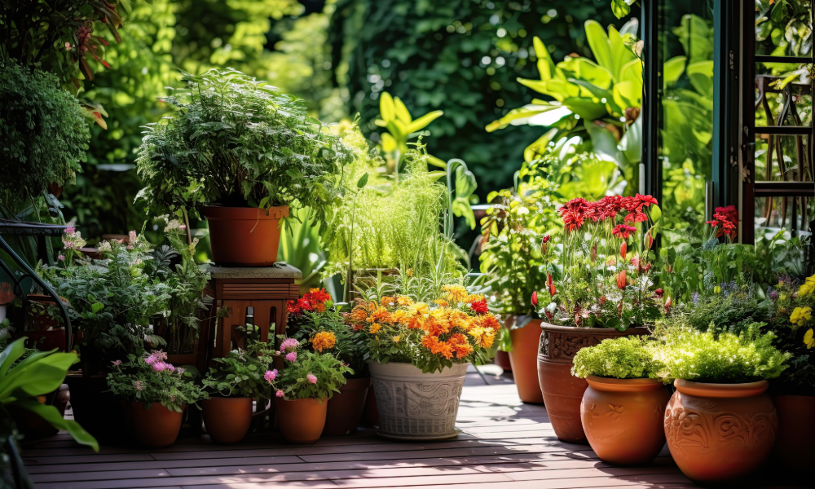

Step 4: Pick the Perfect Balcony Plants
Here is the list of the best flowering plants.
- Hibiscus
- Rose
- Bougainvillea
- Marigold
- Petunia
They add colour and freshness, along with pollinators, to your balcony.
The following are the best low-maintenance green plants.
- Snake Plant
- ZZ Plant
- Areca Palm
- Money Plant
- Spider Plant
They are perfect for busy plant parents.
The following are the best herbs for balcony gardening.
- Basil
- Mint
- Rosemary
- Thyme
- Coriander
- Curry Leaves
Fresh herbs elevate your cooking instantly.
The following are some edibles to grow in small balconies.
- Cherry tomatoes
- Chillies
- Spinach
- Spring onions
- Beans
- Lettuce
Grow bags work best for these plants.
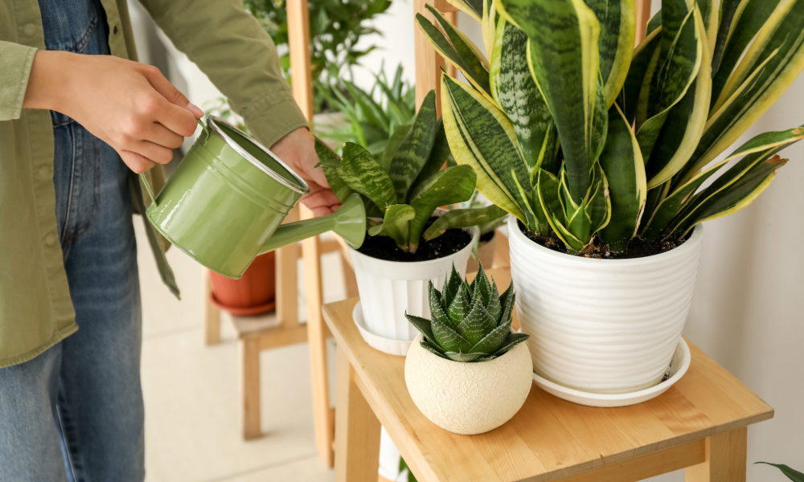

Step 5: Watering the Right Way
Balcony plants often fry out faster due to the wind. Here are some useful tips.
- Water early morning or late evening.
- Check soil moisture before watering.
- Add mulch to keep the soil cool.
- Sue herself wears pants for convenience.
Sulculets need the least water, and the vegetables may need watering daily in summer.
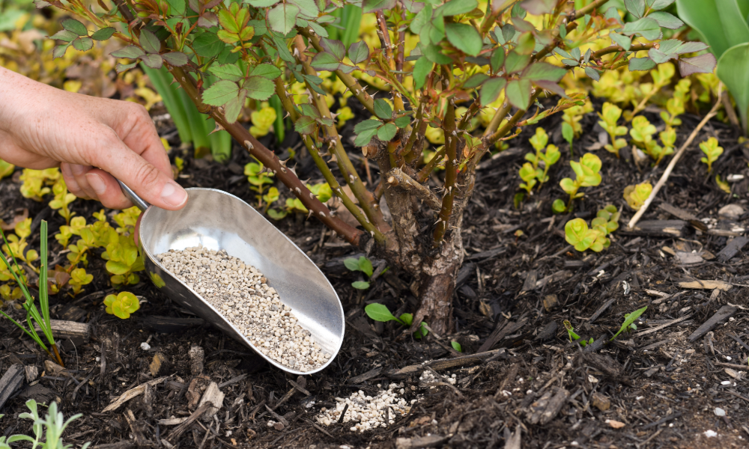

Step 6: Feeding Plants with Fertiliser
Health plans need nutrients.
Here is a list of the best natural fertilisers.
- Compost
- Vermicompost
- Seaweed extract
- Mustard cake water
- Banana peel fertiliser
Feed our plants every 2 to 3 weeks for best results.
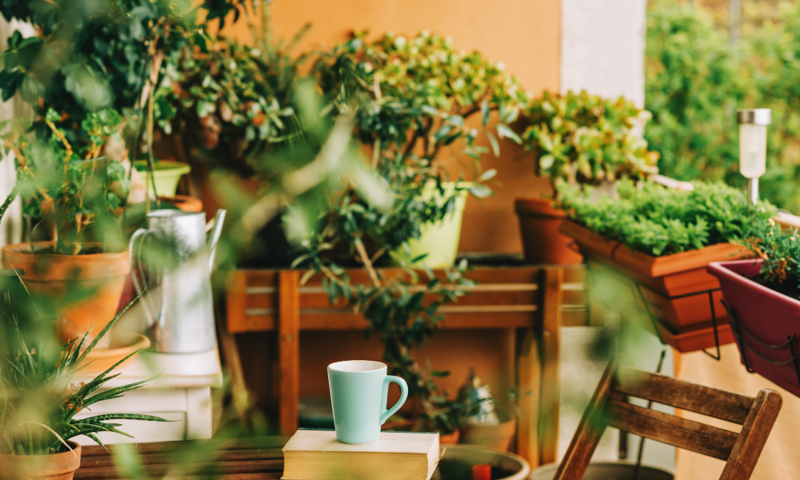

Step 7: Balcony Garden Decor Ideas
Turn your balcony into a stunning green corner.
- String lights around the railing
- Add an aspen or bamboo plant stand
- Use colourful planters
- Include wind chimes for a soothing vibe
- Add a small stool or bench
- Use jute hanging planters for an earthy feel
Small design touches make the space feel magical.
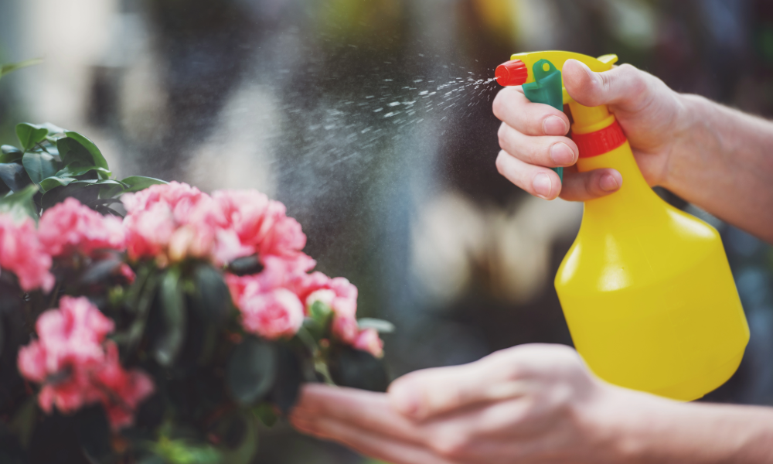

Step 8: Preventing Pests Naturally
Common balcony pests include aphids and mealybugs, as well as mites. Here are some simple remedies.
- Neem oil spray
- Soap water spray
- Wiping leaves with a damp cloth
- Removing heavily infected leaves
Regular cleaning prevents most problems. Keep plants healthy with clean leaves and good drainage, added with weekly inspections. Introduce natural remedies such as garlic or chilli water. Avoid overwatering. It is because damp soils attract pests and fungal infections easily.

Final words
A balcony garden is an investment in your peace and mood as well as your lifestyle. The right setup can make even the smallest balcony into a beautiful green escape. Every step contributes to a lush and soothing solace you will love spending time in.
A balcony garden is not just a collection of plants. It is a personal sanctuary where you can breathe and unwind. You can reconnect with nature without leaving your home. Thoughtful planning and consistent but simple care routines can make your balcony change into a vibrant mini ecosystem full of colour and fragrance, as well as life.
The joy of watching something grow with your care is unmatched, even if you start with just a few pots of herbs or a flowering plant for the garden. Your balance becomes more than a garden over time. It becomes a reflection of your personality and creativity, as well as love for a peaceful green living.

FAQs
Which plants are best for a beginner friendly balcony garden?
Herbs like mint and basic or hardy plants like snake plants, money plants, succulents and jasmine or marigolds are easy to grow and maintain.

How much sunlight does a balcony garden need?
Most plants need 4 to 6 hours of sunlight daily. But shade loving plants such as ferns and synovium and peace lilies grow well in low light balconies.

Can vegetables grow on a small balcony?
Yes. you can grow tomatoes and chillies, spinach, cherry tomatoes, beans, curry leaves, ,emigrass and mireen in pots or vertical planters.

